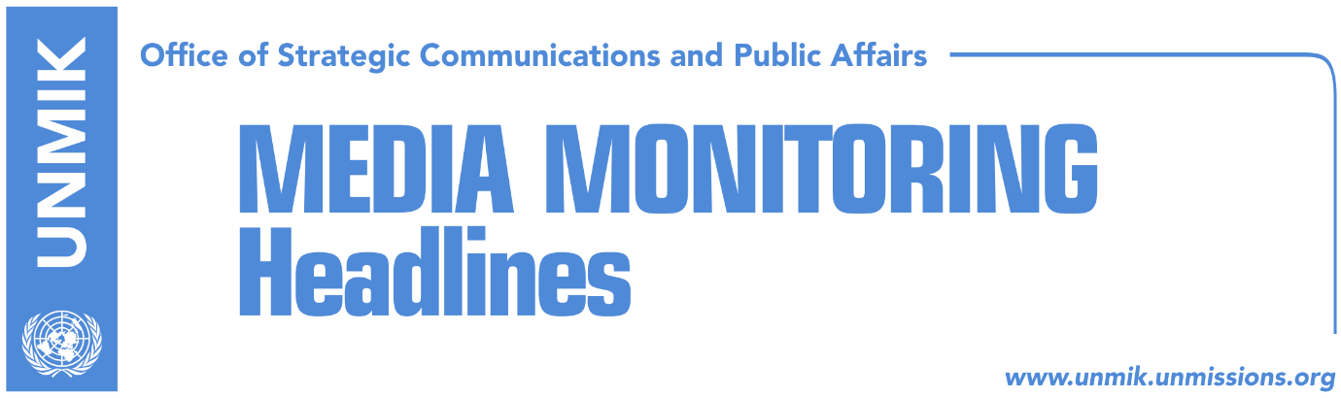

Main Stories 19 February 2019

- Mogherini: No dialogue as long as tax is in force (dailies)
- Haradinaj: Tax will not be lifted while I am Prime Minister (Epoka)
- Divisions between ruling coalition partners deepen (dailies)
- Haradinaj: We are blessed to have U.S. friendship (Zeri)
- Hoti: New elections, broad-based government before dialogue resumes (media)
- Platform doesn’t ask Serbia to recognize Kosovo’s territorial integrity (Koha)
- Serwer makes remarks on Kosovo’s platform (Kosova Sot)
- EU against government’s decision to remove excise on tobacco (media)
- Veseli at World Business Angels Investment Forum in Istanbul (Epoka)

Kosovo Media Highlights

Mogherini: No dialogue as long as tax is in force (dailies)
The EU High Representative for Foreign Affairs and Security Policy, Federica Mogherini, said that there can be no Belgrade-Pristina dialogue for as long as the import tariff on Serbia and Bosnia remains in place. Mogherini said the tariff needs to be lifted or suspended to pave way for a new meeting between President of Kosovo Hashim Thaci and President of Serbia Aleksandar Vucic. She said she would be ready to host as many meetings as required to get the parties reach agreement. “Once the conditions are met, I would be ready not only to restart dialogue the next day but to lock us in for as long as it takes, a week, a month or three months,” Mogherini said following a meeting of EU ministers in Brussels. Mogherini said she expects Belgrade and Pristina to create a positive atmosphere to reach a comprehensive agreement on full normalisation of relations.

Haradinaj: Tax will not be lifted while I am Prime Minister (Epoka)
The Prime Minister of Kosovo Ramush Haradinaj, said on Monday at the memorial complex in Glogjan, that 100-percent import tariff on products from Serbia and Bosnia and Herzegovina will not be lifted as long as he is Prime Minister. He added that Kosovo will not set back in the dialogue with Serbia. “We do not allow opening and alienation of the 17 February independent Kosovo. A population that underwent genocide and persecuted, with around twenty thousand women raped and fifteen thousand dead, now must give something in order to be recognized? In fact, the political right by all norms would have been recognition by Serbia as an apology for what they did in Kosovo, not only during the last war, but even during earlier phases,” Haradinaj said.
Divisions between ruling coalition partners deepen (dailies)
Zeri and Epoka e Re both report today on their front pages about the deepening of divisions between the ruling coalition partners. Zeri says this was evident during activities to mark 11th anniversary of Kosovo’s declaration of independence where Prime Minister Ramush Haradinaj and Assembly Speaker Kadri Veseli are reported to have voiced criticism of one another. The main reason behind this worsening of relations, according to the paper, is the government’s decision to impose tariffs on products from Serbia and Bosnia which Veseli argues should be suspended while Haradinaj insists he will not lift it until Serbia recognises Kosovo. Most recently, Veseli is quoted to have mentioned the possibility of the coalition breakup but did not link it to the tax. Instead, he said this could happen for the sake of the interests of the people of Kosovo. To this statement, Haradinaj is said to have issued an insult to Veseli as he was stepping out of the Assembly session. Haradinaj nevertheless denied this. Meanwhile, analyst Shkelzen Maliqi told Epoka e Re that there is no room for the coalition partners to continue their joint journey and that the situation needs to be unblocked before March as Kosovo cannot afford to be held responsible for the stalling of the Brussels dialogue. Maliqi argued that a new coalition would have to be reached between the Democratic Party of Kosovo (PDK), Social Democratic Initiative (NISMA), New Kosovo Alliance (AKR), Social Democratic Party (PSD) as well as the Democratic League of Kosovo (LDK).

Haradinaj: We are blessed to have U.S. friendship (Zeri)
Prime Minister of Kosovo, Ramush Haradinaj, said Kosovo is blessed to have the friendship of the U.S. In a Facebook post following a meeting with a delegation from the U.S., Haradinaj wrote: “We are blessed with permanent and unique relations we have built with our American friends based on the highest human values. God bless our two peoples.”

Hoti: New elections, broad-based government before dialogue resumes (media)
Avdullah Hoti, head of the Democratic League of Kosovo (LDK) parliamentary group, said on Monday that the current government lacks legitimacy and therefore cannot represent Kosovo in any process. Hoti said that before dialogue with Serbia resumes, there needs to be an agreement on early elections and a broad-based government. “Kosovo needs a legitimate government; we need new elections so that the people can express their will. As this process [dialogue] is so important, we all need to sit down together and form a broad-based government,” he added.

Platform doesn’t ask Serbia to recognize Kosovo’s territorial integrity (Koha)
The paper reports on its front page that “there are flaws” in the most platform adopted by Kosovo’s state delegation for talks with Serbia. The paper notes that the platform calls on Serbia to respect – and not recognize – the sovereignty and territorial integrity of the Republic of Kosovo.

Serwer makes remarks on Kosovo’s platform (Kosova Sot)
The U.S. expert on Balkans Daniel Serwer, made on Sunday remarks on the Platform document submitted by the Kosovo state delegation team to the President of the Assembly of Kosovo Kadri Veseli. Serwer, who pointed the positive and negative points of this platform, stressed that it lacks clarity on how and when UN membership will occur. “It may be implicit in the reference to UNSC approval of the agreement, but it will need to be explicit before the negotiations are concluded. The controlling powers are China and Russia: how will they be brought around to allow a breakaway province to enter the UN? China won’t like it because of Tibet. Russia may like it but will want a quid pro quo in Crimea and possibly also South Ossetia, Abkhazia, and Transnistria.”
Serwer’s remarks can be found at https://www.peacefare.net/

EU against government’s decision to remove excise on tobacco (media)
The European Union is opposing a decision by the Kosovo government to lift the excise on tobacco. The EU Office in Pristina told KTV that this decision goes against the Stabilization/Association Agreement. The EU Representative in Kosovo, Nataliya Apostolova, has advised the government to withdraw the decision. On the other hand, Fatmir Gashi, Deputy Minister of Finance, said he was confident that the government’s decision does not violate the agreement.

Veseli at World Business Angels Investment Forum in Istanbul (Epoka)
The President of the Assembly of Kosovo Kadri Veseli participated on Monday at the World Business Angels Investment Forum in Istanbul. Organizers honored Veseli with a prize at this forum where leaders from different countries of Balkans, Europe and Africa are participating, as one of the best leaders in southeastern Europe, in promotion and supported of youth in the field of information technology. Veseli invited foreign investors to invest in Kosovo saying that it has great capacities and innovative youth.

Disclaimer
This media summary consists of selected local media articles for the information of UN personnel. The public distribution of this media summary is a courtesy service extended by UNMIK on the understanding that the choice of articles translated is exclusive, and the contents do not represent anything other than a selection of articles likely to be of interest to a United Nations readership. The inclusion of articles in this summary does not imply endorsement by UNMIK.

