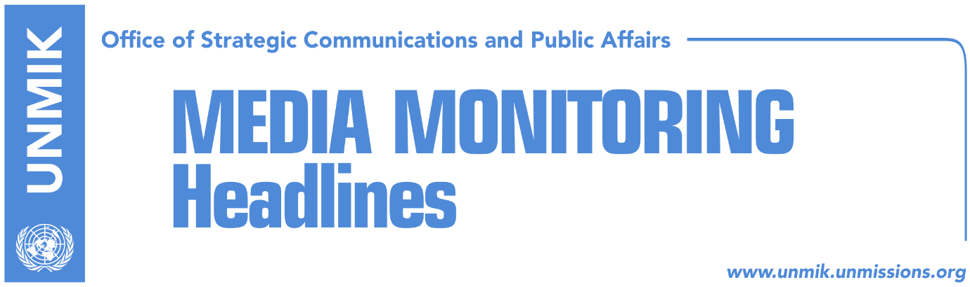

Main Stories 20 February 2019

- Haradinaj claims Mogherini led secret Kosovo-Serbia talks (media)
- Kocijancic: Final Kosovo-Serbia agreement to be sustainable and realistic (RTK)
- PDK tries to avoid early elections by seeking partnership with LDK (Koha)
- Pacolli calls for urgent meeting of Kosovo leaders with U.S. officials (media)
- Hoti: We are waiting to collect 61 signatures to bring Haradinaj down (T7, RTK)
- Ahmeti: PSD will not help PDK overthrow Haradinaj-led government (media)
- Ymeri: LDK wants an all-inclusive government (RTV Dukagjini, RTK)
- Nitaj: No cooling of relations between coalition partners (Epoka e Re)
- EP delegation to visit Serbia and Kosovo (Bota Sot)
- Kosovo to open new embassies (Klan Kosova)

Kosovo Media Highlights

Haradinaj claims Mogherini led secret Kosovo-Serbia talks (media)
Prime Minister of Kosovo Ramush Haradinaj has accused the EU High Representative for Foreign Affairs and Security Policy Federica Mogherini for, as he said, leading secret talks between Pristina and Belgrade. In a press conference following the meeting of the government yesterday, Haradinaj said: “Mogherini has led a half-secret dialogue. It would be good if she shed light on that dialogue.” Koha Ditore unsuccessfully reached out to Kosovo government to comment on Haradinaj’s statement. Haradinaj also reiterated that that import tariff on Serbia and Bosnia and Herzegovina will not be lifted: “We are on the path towards a final agreement with Serbia. If at this stage we begin making steps back, many more such steps will be required of us. This is not only about the tax, I assure you,” Haradinaj said.

Kocijancic: Final Kosovo-Serbia agreement to be sustainable and realistic (RTK)
After the statement of Serbia’s Foreign Minister Ivica Dacic that “the demarcation is Belgrade’s official proposal in the negotiations with Pristina”, European Commission Spokesperson Maja Kocijancic told Tanjug that the final agreement needs to be implementable, sustainable and realistic. “The work on a legally binding agreement on comprehensive normalisation that would lead to a lasting, implementable and sustainable solution for all open questions, based on mutual acceptance, in line with international and EU law and acceptable for all member states, is currently ongoing,” Kocijancic said. She repeated that the comprehensive, legally binding agreement on normalisation, which is covering all open issues, is “urgent and crucial” for the progress of Serbia and Kosovo on their EU paths, as well as peace and stability in the region.

PDK tries to avoid early elections by seeking partnership with LDK (Koha)
The paper quotes different sources as saying that for weeks now the Democratic Party of Kosovo (PDK) is trying to convince the Democratic League of Kosovo (LDK) to join the government in an effort to avoid early elections. To this end, LDK is reported to have been promised the post of prime minister. LDK in turn has rejected the offer but is not completely against the idea of joining the government and has conditioned it with the formation of a broad-based government whereby no party would remain outside. Prime Minister Ramush Haradinaj did not comment on whether he is aware of his coalition partner, PDK, trying to oust him from the post but did say that if such a plan is being prepared, it “will only take five minutes to settle everything.” At the same time, PDK has denied it is negotiating changing coalition.

Pacolli calls for urgent meeting of Kosovo leaders with U.S. officials (media)
Kosovo’s Foreign Minister Behgjet Pacolli called all Kosovo political leaders for an urgent meeting with the officials of the U.S. to coordinate actions that would be in interest of friendship with western allies. Recalling two recent letters from the U.S. administration urging Kosovo leaders to speak in one voice and to seize the moment to reach agreement with Serbia, Pacolli said Kosovo is not the center of the world and will never be, therefore it should be grateful to the U.S. support. “Time is running out, this is the moment of great decisions,” Pacolli wrote.

Hoti: We are waiting to collect 61 signatures to bring Haradinaj down (T7, RTK)
Avdullah Hoti, caucus of the Democratic League of Kosovo (LDK) told T7 that he has collected signatures to bring Ramush Haradinaj’s government down in his office, however he added that he could not reach the required 61. He added that any political party, including the Serbian List, interested to bring down the government, has his door open. However, he added that they would not accept any concessions to the Serbian List in exchange for signatures.

Ahmeti: PSD will not help PDK overthrow Haradinaj-led government (media)
Leader of the Social Democratic Party (PSD) Shpend Ahmeti rejected reports in the media suggesting his party would join a coalition government led by the Democratic Party of Kosovo (PDK) but without the Alliance for the Future of Kosovo (AAK). “We continue to give political support for the tax and are part of the state delegation for dialogue. We have told LDK and VV that we will not help the Serbian List to overthrow the Government because of the tax. We now tell the PDK that we will not overthrow or threaten the AAK as a way of pressure for the Prime Minister to lift the tax,” Ahmeti wrote on Facebook.

Ymeri: LDK wants an all-inclusive government (RTV Dukagjini, RTK)
Visar Ymeri, deputy leader of the Social-Democratic Party (PSD) said his political party is not interested to bring the government down due to the t100-percent tariff on Serbian products. “The idea for an all-inclusive government that would take over the dialogue and lead later the country towards new elections, is a long-term idea of the Democratic League of Kosovo (LDK.) However, we have not seen so far concrete steps from LDK,” Ymeri said.

Nitaj: No cooling of relations between coalition partners (Epoka e Re)
In an interview with the paper, deputy leader of the Alliance for the Future of Kosovo (AAK) Muharrem Nitaj said there is no cooling of relations between the coalition partners and that it is more about the differences of views “over the methodology for reaching the final goal which is the agreement between Kosovo and Serbia.” “The coalition is functioning well,” Nitaj said. He also rejected the idea of a broad-based government calling it ‘ridiculous’ and stated that this would not be a good time for Kosovo to head to elections. “We are facing important processes for the country and someone is making calculations for how to get to power and doesn’t care if this delays Kosovo in vital Euro-Atlantic integration processes,” he said.

EP delegation to visit Serbia and Kosovo (Bota Sot)
A delegation from the European Parliament headed by the chairman of the Foreign Affairs Committee, David McAllister, is expected to undertake an official visit to Serbia and Kosovo. The EP delegation has not specified the topics it will discuss but MEPs are expected to focus on issues of European integration process and the dialogue for normalisation of relations between Pristina and Belgrade.

Kosovo to open new embassies (Klan Kosova)
Kosovo’s Foreign Ministry has announced that it plans to open new embassies in several countries including Thailand, Bangladesh, Colombia, and Ghana. The Ministry said these diplomatic representations will be opened this year as a way to deepen cooperation and partnership with these countries.

Disclaimer
This media summary consists of selected local media articles for the information of UN personnel. The public distribution of this media summary is a courtesy service extended by UNMIK on the understanding that the choice of articles translated is exclusive, and the contents do not represent anything other than a selection of articles likely to be of interest to a United Nations readership. The inclusion of articles in this summary does not imply endorsement by UNMIK.

